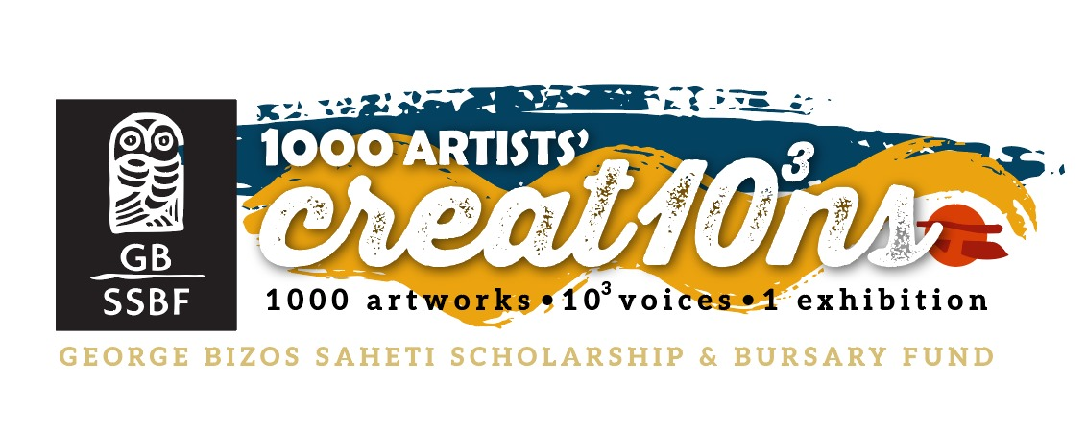
Artists’ call: GBSSBF Heritage Day Inspired Exhibition
UNITY in DIVERSITY – Celebrating 30 Years of our South African Democracy

This Heritage Month, the George Bizos SAHETI Scholarship and Bursary Fund (GBSSBF) invites artists of all ages and backgrounds to participate in a special exhibition titled UNITY in DIVERSITY, celebrating three decades of South African democracy. In the spirit of Heritage Day and in honour of the visionary, human rights advocate George Bizos, we call on you to create a 2D artwork on A2 paper, inspired by the richness of South Africa’s cultural tapestry and the ideals of unity, freedom, and justice that underpin our democratic journey.
Each artwork will form part of a powerful collective installation – a “1000 artworks” exhibition – which will be unveiled during the Arethe Bizos Annual Exhibition in 2026. This initiative honours the legacy of George Bizos, whose unwavering dedication to human rights and education continues to inspire a more inclusive, compassionate future.
The George Bizos SAHETI Scholarship and Bursary Fund (GBSSBF) continues the legacy of advocate George Bizos by providing vital scholarships and bursaries that enable deserving learners to access quality high school education at SAHETI School. Rooted in Bizos’ unwavering belief in the power of education and the Hellenic ideals of justice, compassion, and excellence, the Fund supports all young South Africans in building strong foundations for their futures. Through this work, the GBSSBF honours Bizos’ passion for empowering youth and fostering unity through opportunity—values that align deeply with the theme of this year’s Unity in Diversity exhibition, to which artists are warmly invited to contribute.
Artists are invited to donate their pieces for this cause. Works will be sold anonymously – names of artists will only be revealed after the works are purchased, ensuring each piece is appreciated for its message and impact, rather than reputation. For this reason, please sign your work on the back only.
Let your voice be one among a thousand – and help us celebrate the diversity that unites us all.
The Exhibition.
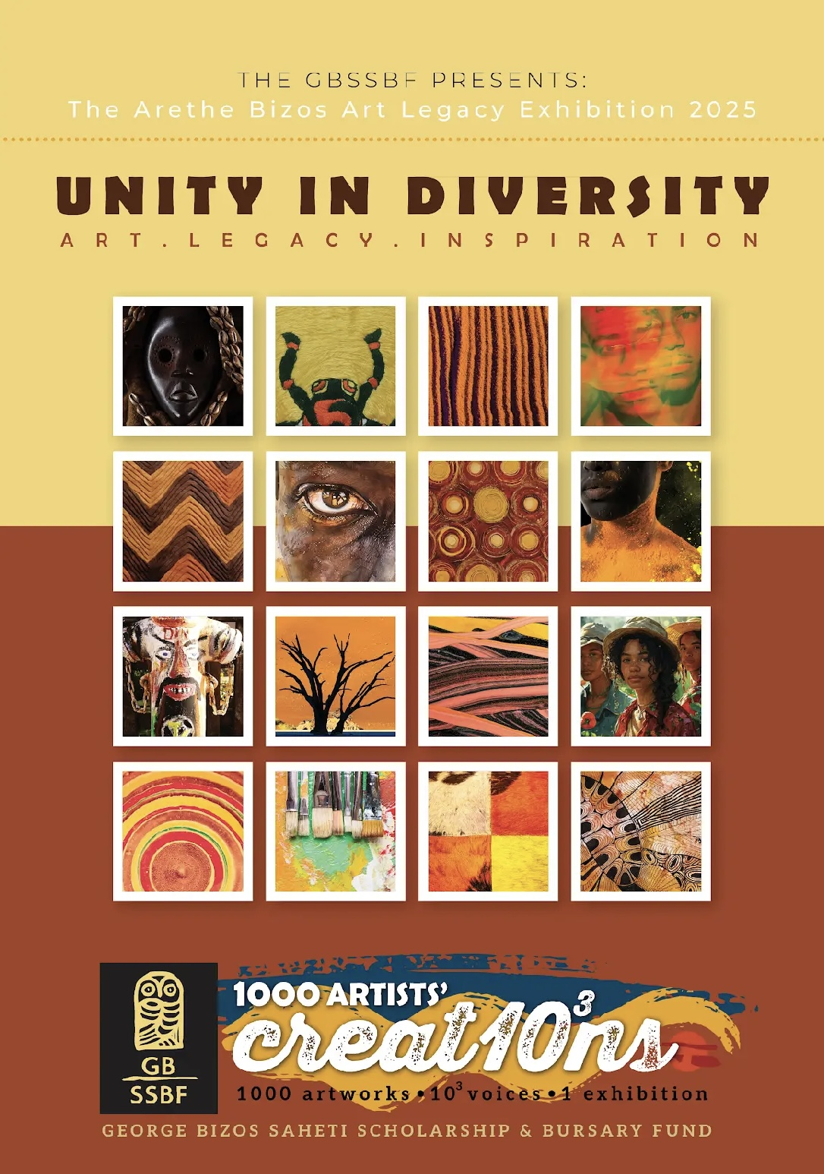

1000 Voices, 1 Exhibition.

Weaving the theme of South Africa’s Heritage Day into the Unity in Diversity concept opens up powerful ground around shared identity, diversity, collective memory, and cultural pride. The aim should be to honour both individual heritages and the unity that emerges from them.

Art. Legacy. Inspiration.

Launching during Heritage Month 2025 and throughout 2026, Unity in Diversity, brings together a chorus of South African artists, young, old, amateur, professional, established or emerging, whose work speaks to identity, memory, and the living energy of culture.
Each piece in this collection is a voice— telling a story of where we come from, what we carry, and how we continue. In a country, not only shaped by the tensions of our history, but the vision of unity in diversity, coexistence, cultural wealth and transformation, this exhibition offers not a single truth, but a shared space where many can be heard.
From reimagined traditions to urgent contemporary expressions, these works celebrate the inheritance of art as a vessel of legacy, resistance, and imagination. The exhibition is not just a reflection on the past, but a creative act of becoming — where the next generation shapes what heritage can mean.
1000 Voices, 1 Exhibition is a call to listen. To honour the histories that shape us. And to celebrate the boundless creative force of South Africans.

Our Vision.
Through drawing, printmaking, photography, painting, and multimedia works, the exhibition will showcase how art can serve as a bridge between different cultural backgrounds, histories, and narratives. Visitors will encounter pieces that highlight local stories, struggles for belonging, and the shared spaces that shape communal life. The aim is to inspire reflection on how creative expression can build understanding and strengthen bonds in a post-apartheid society still healing from division. We are calling on artists to help us build a new vision of the future built on truth, honesty and the values of mutual respect, know thyself, ubuntu and civic responsibility.

Overview and parameters.
- Artists may participate in the exhibition by filling the form provided at the end of this artists’ call, and by confirming their commitment to exhibit with us by emailing their details to art@georgebizos.com.
- The format of each artwork must be, strictly, no larger than and A2: 59cm x 42cm. You may include a 3 cm blank border around the work if you wish to sign in front- (please refer to the fundraising section below for further clarity).
- For drawings, paintings, prints, digital prints please ensure that you use a good quality art paper, preferably above 250gsm. For oil paintings, use no thicker than a 6mm primed board; if you choose to work on canvas, the canvas must be taken off the stretcher and trimmed to size, before delivering. For photography, please ensure that you print on a 250gsm equivalent, professional paper.
- Any 2-dimensional work is acceptable: drawing, printmaking, photography, painting, and multimedia or digital works.
- You may enter up to 3 works (per individual artist)
- Works must only be signed at the back. (kindly refer to the fundraising section below for further clarity).
- The final date of submissions for all works – 20 April 2026.
- All (physical) works must be delivered to SAHETI School, (details to be announced), or to the exhibition curator Yannis John Generalis (at an address in Johannesburg which will be announced closer to the time). Kindly communicate via email to make arrangements: art@georgebizos.com or john@georgebizos.com.
- Digital contributions can be emailed to: art@georgebizos.com or john@georgebizos.com.
- Simultaneously to the delivering the work, a clear photo as well as a short (1 paragraph motivation) about the artwork, including title and your full name and surname must be emailed to art@georgebizos.com.
- Your actual artworks will be donations to the GBSSBF, and whilst intellectual property remains with the artist, the GBSSBF will own the works, to sell, market or display as part of their 2026 fundraising drive.
- The project will begin with the first exhibition of works contributed by primary school learners at SAHETI School, at an initial exhibition titled UNITY in DIVERSITY, part of the annual GBSSBF Arethe Bizos exhibition, date to be announced.
- The exhibition will be shown again, in collaboration with other institutions, in 2026, which will include all 1000 artworks on show.
- As a participant you will be invited to all public showings/ exhibitions of the project.
- The artworks must relate and comply with the parameters outlined above, adhering to the theme and intentions of the GBSSBF’s vision. Works that might not comply, will be rejected by the GBSSBF. The committee’s decision in this regard, will be final.

Notes to participating schools and teachers.

- If this project forms part of an art-class or class project, you need only submit 1 form, stating the number of learners/teachers participating.
- However, when emailing the photos of the individual works (see above), kindly include name, surname, grade of each learner; as well as individual title of each artwork (if applicable), or class/team/art-project (overall) title.
- If a group motivation was given to the learners, kindly send us a one paragraph motivational for the specific group.
- For all participating learners/school students only: The GBSSBF will offer a voucher for art materials/supplies as first prize – to the value of R2000- to one selected learner artwork submitted. The panel’s decision will be based on the outlines of the project as outlined in this document and will be final. The winner will be announced at the opening of the exhibition.

Our 2025/26 fundraising drive.

All the artworks that form part of the UNITY in DIVERSITY exhibition, will be made available to the public to buy, by purchasing a 1000 Creat10³ns ticket ahead of the opening and exhibition event.

The works will include works from school learners, art students, amateur and professional artists. Buyers may select a work from numbered visuals provided on our website or participate “blindly” (see options 1 & 2 below).

This will work on a first-come first serve basis and will be linked to proof of payment by the buyers.
Works will be sold anonymously – names of artists will only be revealed after the works are purchased, ensuring each piece is appreciated for its message and impact, rather than reputation. For this reason, please sign your work on the back only. (If you wish to sign in front, please allow for an extra 3 cm border.)
As described above, all proceeds from this fundraising project will be contributing to financial support, through bursaries, for deserving students.
For the public to participate in this exciting project, the GBSSBF, will be selling 1000 Creat10³ns tickets.
Option 1= Each ticket bought will be allocated to a random artwork. In this way, the buyer may receive a work from any artist, whether this is a primary school learner, an up-and coming art student, or a professional:
Each 1000 Creat10³ns ticket, will be sold for ZAR500.
Option 2 = (only available to parents of participating learners/school students). If a buyer would like to specify, which learner/school student work, they wish to select from the listed, numbered photos displayed on our website at the time:
Each 1000 Creat10³ns ticket, will be sold for ZAR600.

In conclusion.
We at the GBSSBF, we have always strived to uphold the ideals of a classical Hellenic education. We honour the rich heritage entrusted to us by visionary South Africans — among whom our beloved George Bizos holds a special place. In carrying his legacy forward, we remain committed to his enduring vision: To educate is to inspire, nurture, empower and to invest in our youth, forging a brighter future for generations to come.
You, our friends, supporters, contributors and patrons, help us achieve this vision by participating in projects such as this.
Thank you for your unwavering support.

In 2026 let’s honour our heritage, make art, buy art, make a difference!
Unity in Diversity

Below you will find the participation form for the exhibition.
Kindly email this form to art@georgebizos.com, to secure your participation.

UNITY IN DIVERSITY – EXHIBITION PARTICIPATION FORM

George Bizos SAHETI Scholarship and Bursary Fund (GBSSBF)
Celebrating 30 Years of South African Democracy

Please complete the form below in full:
Full Name of Artist: | ________________________________________________
Email Address: | ________________________________________________
Mobile Number: | ________________________________________________
Number of Works to be Submitted: | ______
Date: | ____ / ____ / 2026
Signature: | ________________________________________________

DISCLAIMER:
By signing and submitting this form, the artist confirms that they have read and understood the full rules, terms, and conditions governing participation in the "Unity in Diversity" exhibition.

All artworks submitted for this GBSSBF fundraising exhibition become the property of the George Bizos SAHETI Scholarship and Bursary Fund for purposes of sale, promotion, marketing, and any exhibition-related matters. While the intellectual property rights of each artwork remain with the artist, the physical artworks themselves will not be returned, and may be used to further support the objectives of the GBSSBF, in line with its mission of funding secondary school education at SAHETI School through scholarships and bursaries.

